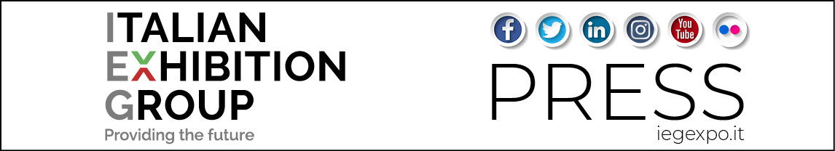

Press Bulletin (English translation)

AN ALL-IN DEBUT FOR THE FULL-DIGITAL EXPO PLATFORM
PLANNED BY IEG

“Live” experiences remain irreplaceable but the digital course supports business development

Rimini, 23rd November 2020 - Ecomondo and Key Energy digital edition 2020 also confirmed the success of the bilingual technological platform planned and designed by IEG - Italian Exhibition Group, a course already undertaken at the end of 2019 and which the world scenario, conditioned by the Coronavirus, accelerated in a format able to exploit professional networking by “users” from all over the world.

CEO Corrado Peraboni says, “A platform conceived to complete and enrich the offer of Italian Exhibition Group’s international expos, but which, due to the restrictions imposed by the government’s recent decrees, was launched testing two ‘full-digital’ expos. The project was adapted in a few days, on the very eve of the expos: from the management of a “hybrid” expo experience, to the definition of a format for the complete online exploitation of business and cultural contents.”
IEG digital manager Simone Zaccherini explains, “We used three launching pads for the platform: one for visitors, who navigated among the expos’ contents, facilitated by personalized suggestions that the project’s artificial intelligence contributed to preparing; a second for exhibitors, providing them the opportunity of being identified by interlocutors who were potentially the most suited to receiving their commercial proposals in multimedia form; the third completely orientated towards cutting edge innovation, with a journey into the future of green technology. The result was 400 companies active out of the 735 involved; 21,000 users active between the 3rd and the 15th November; 33,897 participants in the 140 events on the program, able to be followed live and later on demand.”

Profiling supply and demand enabled to explore all the potentially interesting proposals online, schedule An agenda of meetings, hold reserved chats and video chats to discuss the contents in depth, as well as limiting one’s digital visit to selected product clusters.

Peraboni concludes, “Live experiences remain irreplaceable, but the technological power available is able to exalt enterprises’ innovation and creativity, naturally always starting from the organizational commercial and marketing elements, which rapidly see and interpret trends and new demand. We are on the digital course for multiplying business, but with the helm still firmly set on live expos.”

FOCUS ON ITALIAN EXHIBITION GROUP
Italian Exhibition Group (IEG), listed on the Mercato Telematico Azionario, the main equities market organized and managed by Borsa Italiana S.p.A. (Italy’s stock exchange), is the Italian leader in the organization of trade expos and one of the main players in Europe in the expo and conference sector with its venues in Rimini and Vicenza, as well as its branches in Milan and Arezzo. The IEG Group stands out for the organization of events in five categories: Food & Beverage; Jewellery & Fashion; Tourism, Hospitality and Lifestyle; Wellness, Sport and Leisure; Green & Technology. In recent years, IEG has launched an important process of foreign expansion, also by means of joint ventures inked with local players (e.g. in the United States, Arab Emirates and China). IEG ended the 2019 financial year with a total consolidated turnover of 178.6 million euros, an EBITDA of 41.9 million and a net consolidated profit of 12.6 million euros. In 2019, IEG held a total of 48 organized or hosted exhibitions and 190 conference events. www.iegexpo.it

This press release contains forecast elements and estimates that reflect the management’s current opinions (“forward-looking statements”), particularly regarding future management performance, realization of investments, cash flow trends and the evolution of the financial structure. For their very nature, forward-looking statements have a component of risk and uncertainty, as they depend on the occurrence of future events. The effective results may differ (even significantly) from those announced, due to numerous factors, including, only by way of example: food service market and tourist flow trends in Italy, gold and jewellery market trends, green economy market trends; the evolution of raw material prices; general macroeconomic conditions; geopolitical factors and evolutions in the legislative framework. Moreover, the information contained in this release, does not claim to be complete, and has not been verified by independent third parties. Forecasts, estimates and objectives contained herein are based on the information available to the Company as at the date of this release.

